- after applying TLSv1.2 to Database, Dynamic report exception problem.
We are using dynamic report. By the way after applying TLSv1.2, there is exception error from dynamic report when I run dynamic reports.
Below is our Database (DB) environment:
- TLS 1.2
- Cipher Suite : DHE-RSA-AES256-SHA256
- Using SSL certification
  - 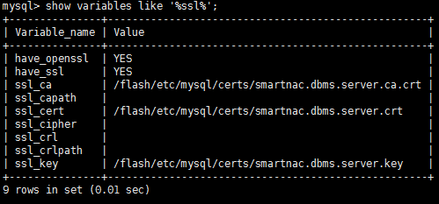

Below is exception information:
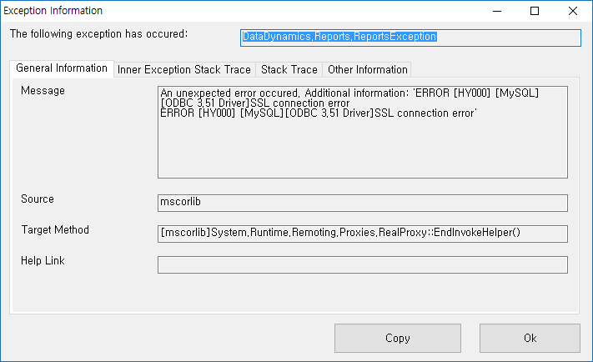

The data being put into report is acquired by ‘Microsoft Odbc Provider’. (See the below figure)
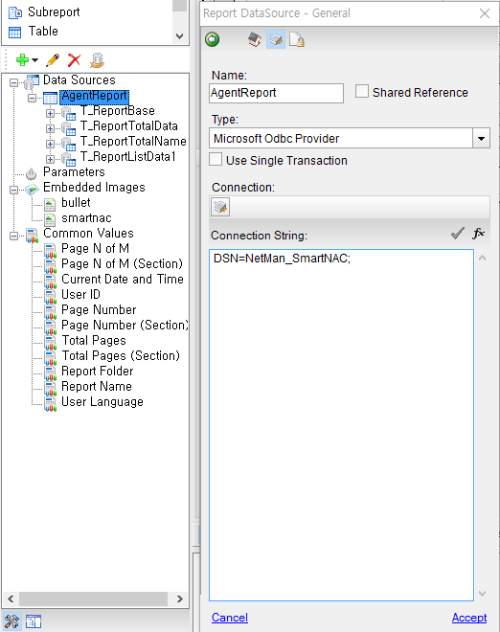
I think it’s a SSL connection fail from error message.
I tried to edit a connection string like that:
=> Driver={MySQL ODBC 3.51 Driver}; Server=XXX.XXX.XXX.XXX; Database=XXXXXX; User=XXXXXX; Password=XXXXXX; sslca=C:\Windows\SysWOW64\smartnac.dbms.server.ca.crt; sslcert=C:\Windows\SysWOW64\smartnac.dbms.server.crt; sslkey=C:\Windows\SysWOW64\smartnac.dbms.server.key; sslverify=1; Option=3;

However, it’s a still not working.

- If I try to edit data source, program abnormally shut down. 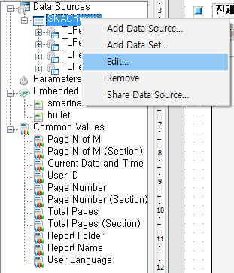
Following error message:
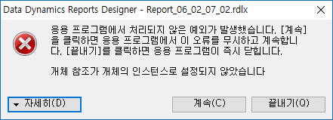
Translation:
Data Dynamics Reports Designer – Report_06_02_07_02.rdlx
Unhandled exception has occurred in your application. If you click [Continue], the application will ignore this error and attempt to continue. If you click [Quit], the application will close immediately.

Object reference not set to an instance of an object.

Detail(D) Continue(C) Quit(Q)

Dynamic Report Designer version information:
Setup file information: Reports.Setup.1.6.2260.3.exe
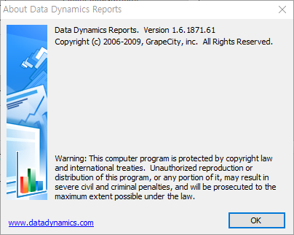
Please answer and explain about above two questions. I have to fix this bugs as soon as possible.
Best regards,

